Time and Frequency Domain Responses of LTIC Systems

LE/EECS 3451 Signals and Systems Lab 2 Report

Names:Hao Liu

ID: 218703991

Due Date: October 28, 2024

Virtually Completed

Table of Contents

Laboratory 2 - Time and Frequency Domain Responses of LTIC Systems 1

Introduction3

Equipment Used 3

Results and Discussion 4

Question 14

Question 1 (2)5

Question 2 (1)6

Question 2 (2)7

Question 2 (3)8

Question 3 (1)9

Question 3 (2)10

Conclusion11

Appendix12

Introduction of Lab 2

In this lab, we explored the use of MATLAB to analyze the time and frequency domain responses of Linear Time-Invariant Continuous (LTIC) systems. Our objectives included examining the dynamic behavior of systems through time-domain analysis, utilizing Fourier series to represent periodic signals, and generating frequency response plots such as Bode diagrams. Through this, we gained a deeper understanding of how LTIC systems respond to different inputs, allowing for practical insights into signal processing and system behavior.

Equipment Used

Because its virtual and is mainly on calculation and MATLAB so just much equipment used.

1. Laptop

1. MATLAB

1. E-class Lecture Notes

Results and Discussion

Q1) 1. L = 2.0 H, C = 0.5 F, R = 1 Ω

𝐼 (𝑡) = 𝑐𝑢𝑟𝑟𝑒𝑛𝑡 𝑡ℎ𝑟𝑜𝑢𝑔ℎ 𝑖𝑛𝑑𝑢𝑐𝑡𝑜𝑟

𝐼 (𝑡) = 𝑐𝑢𝑟𝑟𝑒𝑛𝑡 𝑡ℎ𝑟𝑜𝑢𝑔ℎ 𝑐𝑎𝑝𝑎𝑐𝑖𝑡𝑜𝑟

𝐼 (𝑡) = 𝑐𝑢𝑟𝑟𝑒𝑛𝑡 𝑡ℎ𝑟𝑜𝑢𝑔ℎ 𝑟𝑒𝑠𝑖𝑠𝑡𝑜𝑟

𝑥(𝑡) = 𝐼 (𝑡) + 𝐼 (𝑡) + 𝐼 (𝑡)

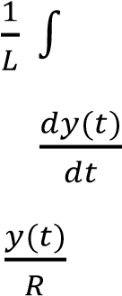 𝐼 (𝑡) = 𝑦(𝑡)𝑑𝑡

𝐼 (𝑡) = 𝐶

𝐼 (𝑡) =



( ) = ( ) + 𝐶 𝑑2 (2 ) + ( )

𝑡

𝑥(𝑡) = 𝑦(𝑡) + 𝐿𝐶 𝑑2 (2 ) + 𝑅𝐶 ( ) ➔ derive both sides of the equation

𝑡

𝑥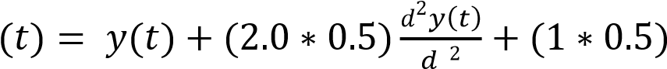( ) ➔ substitute given values

𝑡

𝑥(𝑡) = 𝑦(𝑡) + 𝑦 (𝑡) + 𝑦′′(𝑡) ➔ simplify equation down to final form

∴ 𝒙(𝒕) = 𝒚(𝒕) + 𝟏 𝒚 (𝒕) + 𝒚′′(𝒕) is the di erential equation relating L, C and R

𝟐

2. (i) Zero-input response when 𝑥(𝑡) = 0, 𝑦(0) = 1, 𝑦′(0) = 8:

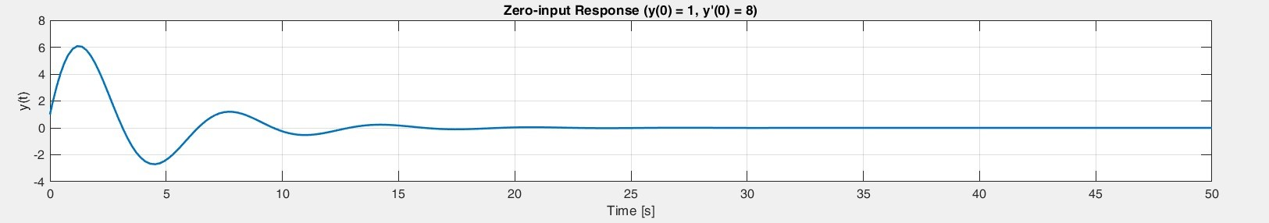

1. Total-output response 𝑦(𝑡) = 2 sin(0.1𝜋𝑡) , 𝑦(0) = 1, 𝑦′(0) = 8:

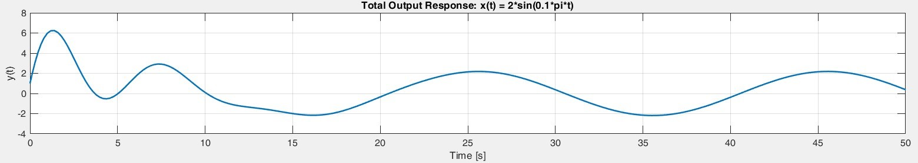

1. Total-output response 𝑦(𝑡) = 2 sin(2𝜋𝑡) , 𝑦(0) = 1, 𝑦′(0) = 8:

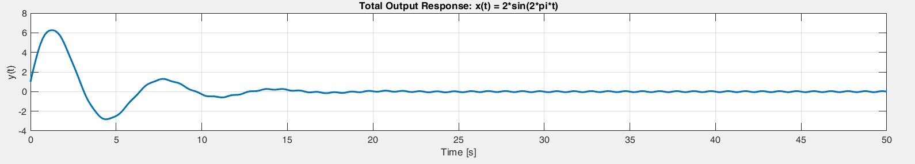

Q2 (1)

Q2 (2)

As we can see here that the y1(t) starting to have a constant wave but still with a bit of uncertainty that cause the wave to not be smooth

Q2 (3)

In y2(t) our signal wave are perfect and smooth.

Q3) 1. 𝑅 = 2Ω, 𝐿 = 1𝑚𝐻, 𝐶 = 10𝜇𝐹

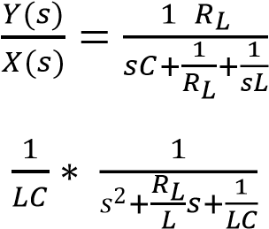 Transfer function 𝐻(𝑠) = /

= ➔ simplify equation

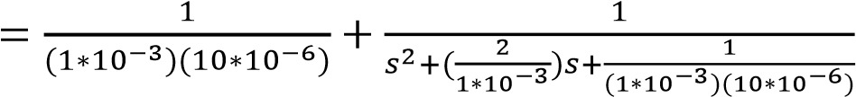 ➔plug values

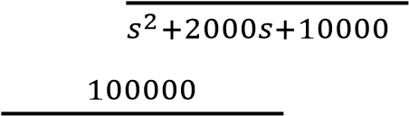 = 100000 + ➔ simplify

𝐻(𝑠) = ➔final transfer function

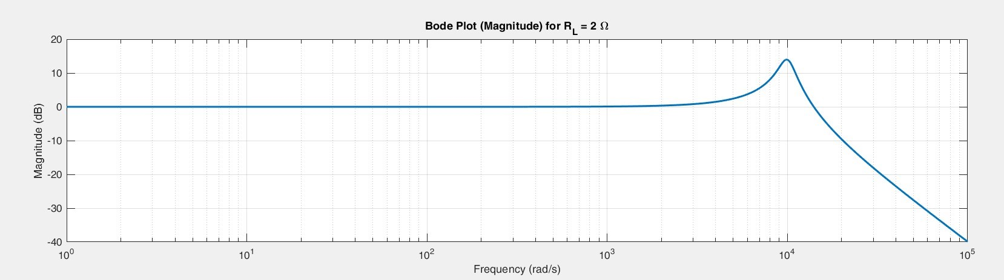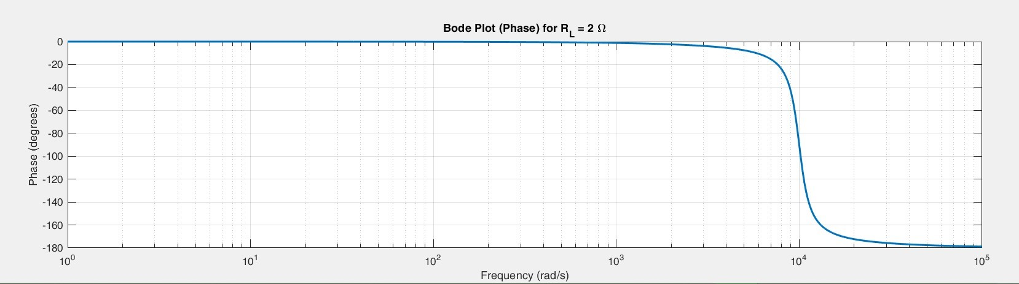

Q3) 2. 𝑅 = 200Ω, 𝐿 = 1𝑚𝐻, 𝐶 = 10𝜇𝐹

 Transfer function 𝐻(𝑠) = /  ➔ taken from q3 pt1

= ➔ simplify equation (taken from q3 pt1)

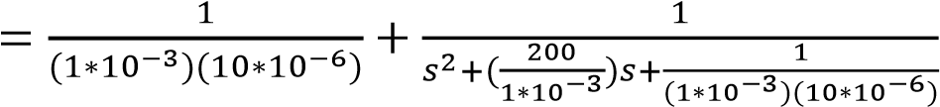 ➔plug values

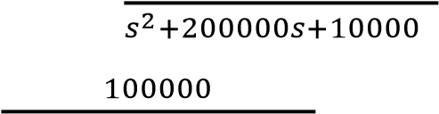 = 100000 + ➔ simplify

𝐻(𝑠) = ➔final transfer function

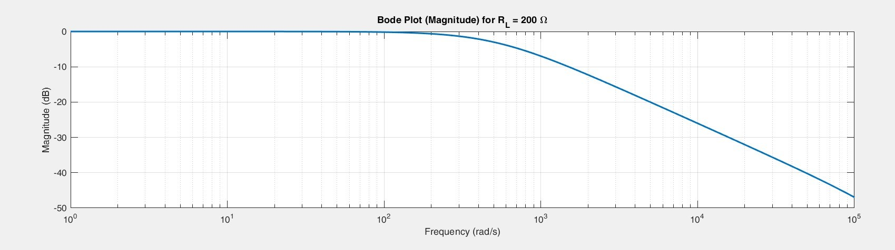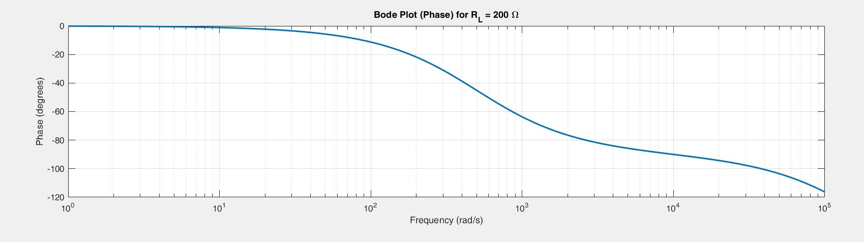

Conclusion

Throughout this lab, we used MATLAB to model and analyze the responses of LTIC systems in both the time and frequency domains. We had a lot of practice on how to derive and solve differential equations representing these systems, plot their output responses, and create Bode plots to visualize their frequency characteristics. These exercises will enhance our ability to interpret signal behavior and understand the principles underlying system stability and resonance. Despite encountering challenges in fine-tuning some plots, the lab effectively reinforced the key concepts in signals and systems.

Appendix

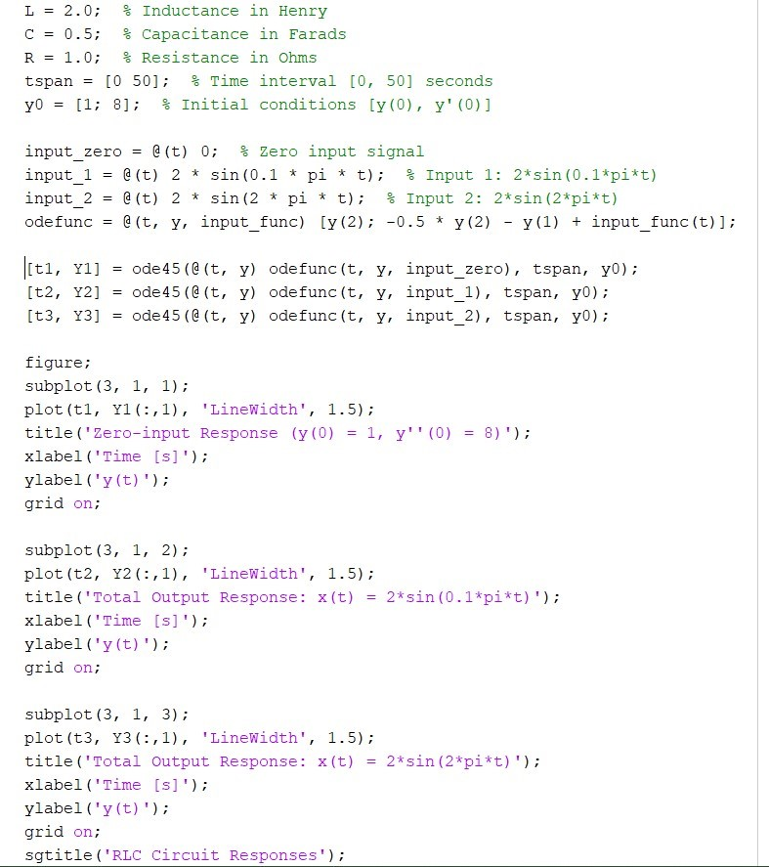Q1) 2)

Q2) (1)

Q2) (2)

Q2) (3)

Q3) 1)

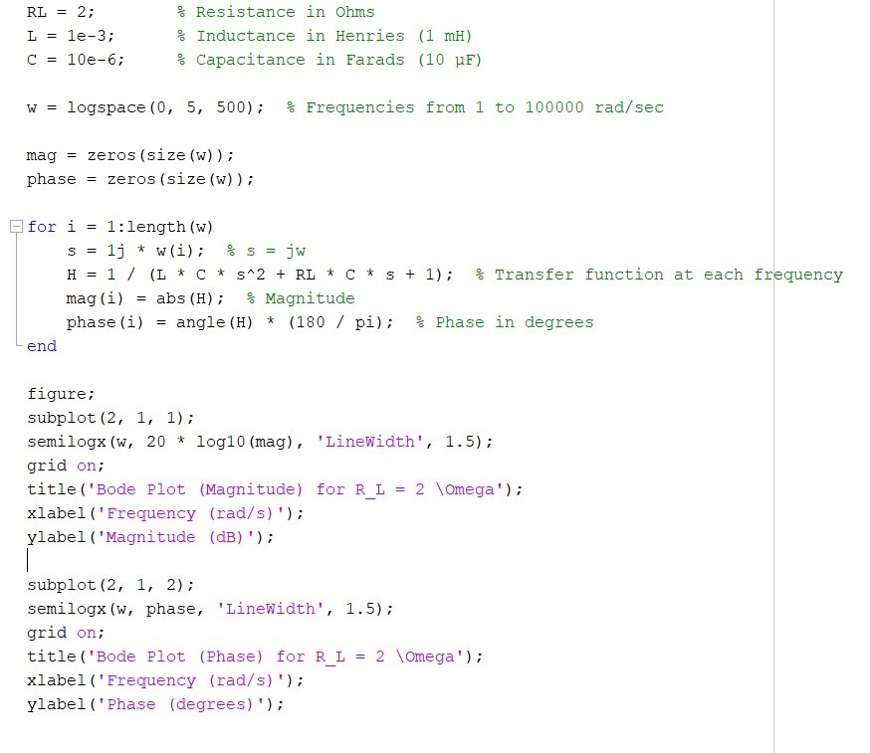

Q3 2)

